1. Sorting Trominoes

1.1 Problem description
For this task, I need to take a square grid with exactly one missing square and fill the entire rest of the board using right trominoes (L shaped blocks made of 3 squares). The tricky part isn't just making the pieces fit, but also having to paint each piece using only three colors. The golden rule is that if two trominoes share a border, they cannot be the same color. It was solved using both a Divide-and-Conquer approach and a Brute Force approach with a comparison between them.

1.2 Assumptions
Before writing the code, a few ground rules were set to make sure everything worked properly:
- Board Size: The classic L tromino puzzle relies on the board being a power of two to divide evenly. So, the solution was structured for a board size of 2^{n} times 2^{n} (like 4x4, 8x8, 16x16).
- The Missing Square: The missing square can be anywhere, with a toggle in the main function to either randomize its placement or force it near the middle for testing.
- What Adjacent Means: The rules say no two trominoes of the same color can share an edge, it was interpreted as flat edges only. If two pieces of the same color only touch diagonally at the corners, that's perfectly fine.
- Grid Values: the missing square had a value of -1 (printed as X), 0 for empty spots, and the numbers 1, 2, and 3 to represent the three colors.

1.3 Methodology

1.3.1 Approach 1: Divide and Conquer
Instead of brute forcing the placements, this method relies on the geometry of the grid. Basically, the algorithm splits the main board into four equal quarters. Since there is only one missing tile on the entire board, it's guaranteed to fall into just one of those quadrants. That leaves the other three completely empty.
The main trick to making this work is placing a single L shaped piece right in the exact center of the board. If oriented correctly, it covers exactly one square in each of those three empty quadrants.
Once that center piece is down, each quadrant acts like a smaller version of the original problem, since they all have exactly one missing or occupied square. From there, recursion is used to keep dividing the board down until the function hits a base case of a 2x2 grid. A 2x2 grid with one missing tile is literally just the shape of one L tromino, so the code drops the piece in and returns.
Handling the Colors:
Trying to figure out the colors at the same time as placing the pieces is difficult. To keep the logic clean, the function is split to two phases. The tiling function just assigns a unique ID integer to every piece it places. After the entire board is full, a separate function (colorBoardRecursive) runs a pass over the IDs. It tests colors 1 through 3, checks the adjacent neighbors to ensure no rules are broken, and just backtracks if it hits a dead end. This methodology could be subject to further optimization.

1.3.2 Approach 2: Brute Force
The brute force method is essentially just a large guessing and verifying loop. The algorithm scans through the 2D array row by row until it hits a 0, meaning it found an empty spot, then it tries to drop an L tromino into that space. Since the piece can be rotated, the four possible shapes are tested by the program to discover which one fits.
If a piece fits without going out of bounds or overlapping another tile, the code immediately tries to paint it with the first color. It checks the adjacent tiles, and if that color doesn't break the adjacency rule, it locks it in and recursively moves on to the next empty square. But if it hits a dead end, when no rotation fits or all three colors are already taken by the surrounding pieces, the backtracking starts to take process. It basically reverts the last move, pulls the piece off the board, and tries the next color or rotation until it eventually brute forces a valid combination.

1.4 Pseudocode
FUNCTION solveDivideAndConquer(board, size, missRow, missCol, currentId):
IF size == 2:
Fill the 3 empty squares with currentId
currentId = currentId + 1
RETURN

halfSize = size / 2
Find the center coordinates of the current board section
Determine which of the 4 quadrants contains (missRow, missCol)
Place a tromino (using currentId) in the center to cover the 3 empty quadrants
currentId = currentId + 1

solveDivideAndConquer(top_left_quadrant)
solveDivideAndConquer(top_right_quadrant)
solveDivideAndConquer(bottom_left_quadrant)
solveDivideAndConquer(bottom_right_quadrant)

FUNCTION colorBoard(currentTromino, totalTrominoes):
IF currentTromino > totalTrominoes:
RETURN True

FOR color = 1 TO 3:
IF color does not match any adjacent tromino:
Assign color to currentTromino
IF colorBoard(currentTromino + 1) is True:
RETURN True
Remove color

RETURN False

FUNCTION solveBruteForce(board):
Find the first empty square (r, c)
IF no empty squares exist:
RETURN True

FOR each of the 4 tromino rotations:
IF the rotation fits at (r, c):
FOR color = 1 TO 3:
IF color is valid:
Place the rotated tromino and assign the color
IF solveBruteForce(board) is True:
RETURN True
Remove the tromino

RETURN False

1.5 Implementation code

1.5.1 Divide and Conquer code
#include <iostream>
#include <vector>
#include <cmath>
#include <iomanip>
#include <cstdlib>
#include <ctime>

using namespace std;

const int MISSING_SQUARE = -1;
const int EMPTY_SQUARE = 0;

void solveDivideAndConquer(vector<vector<int>>& board, int startRow, int startCol, int boardSize, int missRow, int missCol, int& currentId) {

// base case which is 2x2
if (boardSize == 2) {
for (int i = 0; i < 2; i++) {
for (int j = 0; j < 2; j++) {
// fill last 3 squares without missing
if (!(startRow + i == missRow && startCol + j == missCol)){
board[startRow + i][startCol + j] = currentId;
}
}
}
currentId++;
return;
}

int half = boardSize / 2;
int centerRow = startRow + half;
int centerCol = startCol + half;
int myTrominoId = currentId++;

// missing square for each quarter
int nextMissRowTL, nextMissColTL;
int nextMissRowTR, nextMissColTR;
int nextMissRowBL, nextMissColBL;
int nextMissRowBR, nextMissColBR;

// top left
if (missRow < centerRow && missCol < centerCol) {
nextMissRowTL = missRow; nextMissColTL = missCol;
} else {
board[centerRow - 1][centerCol - 1] = myTrominoId;
nextMissRowTL = centerRow - 1; nextMissColTL = centerCol - 1;
}

// top right
if (missRow < centerRow && missCol >= centerCol) {
nextMissRowTR = missRow; nextMissColTR = missCol;
} else {
board[centerRow - 1][centerCol] = myTrominoId;
nextMissRowTR = centerRow - 1; nextMissColTR = centerCol;
}

// bottom left
if (missRow >= centerRow && missCol < centerCol) {
nextMissRowBL = missRow; nextMissColBL = missCol;
} else {
board[centerRow][centerCol - 1] = myTrominoId;
nextMissRowBL = centerRow; nextMissColBL = centerCol - 1;
}

// bottom right
if (missRow >= centerRow && missCol >= centerCol) {
nextMissRowBR = missRow; nextMissColBR = missCol;
} else {
board[centerRow][centerCol] = myTrominoId;
nextMissRowBR = centerRow; nextMissColBR = centerCol;
}

// recursion does the job
solveDivideAndConquer(board, startRow, startCol, half, nextMissRowTL, nextMissColTL, currentId);
solveDivideAndConquer(board, startRow, centerCol, half, nextMissRowTR, nextMissColTR, currentId);
solveDivideAndConquer(board, centerRow, startCol, half, nextMissRowBL, nextMissColBL, currentId);
solveDivideAndConquer(board, centerRow, centerCol, half, nextMissRowBR, nextMissColBR, currentId);
}

bool colorBoardRecursive(vector<vector<int>>& board, vector<int>& assignedColors, int currentTromino, int totalTrominoes) {
if (currentTromino > totalTrominoes) return true;

for (int color = 1; color <= 3; color++) {
bool isSafe = true;
for (int i = 0; i < board.size(); i++) {
for (int j = 0; j < board.size(); j++) {
if (board[i][j] == currentTromino) {
if ((i > 0 && assignedColors[board[i-1][j]] == color) ||
(i < board.size()-1 && assignedColors[board[i+1][j]] == color) ||
(j > 0 && assignedColors[board[i][j-1]] == color) ||
(j < board.size()-1 && assignedColors[board[i][j+1]] == color)) {
isSafe = false;
break;
}
}
}
if (!isSafe) break;
}

if (isSafe) {
assignedColors[currentTromino] = color;
if (colorBoardRecursive(board, assignedColors, currentTromino + 1, totalTrominoes)) return true;
assignedColors[currentTromino] = 0;
}
}
return false;
}

void applyColorsToDC(vector<vector<int>>& board, int maxId) {
vector<int> assignedColors(maxId + 1, 0);
colorBoardRecursive(board, assignedColors, 1, maxId);

for (int i = 0; i < board.size(); i++) {
for (int j = 0; j < board.size(); j++) {
if (board[i][j] != MISSING_SQUARE) {
board[i][j] = assignedColors[board[i][j]];
}
}
}
}

void printBoard(const vector<vector<int>>& board) {
for (const auto& row : board) {
for (int val : row) {
if (val == MISSING_SQUARE) cout << setw(4) << "X";
else cout << setw(4) << val;
}
cout << endl;
}
}

int main() {
int n = 4; // change this, 5 will probably not even finish for bf
int boardSize = pow(2, n);
int missR, missC;

bool randomizeMissing = true; // set to true to randomize missing coord

if (randomizeMissing) {
srand(time(0));
missR = rand() % boardSize;
missC = rand() % boardSize;
} else {
// missing close to center
missR = boardSize / 2 - 1;
missC = boardSize / 2 - 1;
}

vector<vector<int>> startGrid(boardSize, vector<int>(boardSize, EMPTY_SQUARE));
startGrid[missR][missC] = MISSING_SQUARE;

// dac
vector<vector<int>> dcBoard = startGrid;
int trominoCounter = 1;
solveDivideAndConquer(dcBoard, 0, 0, boardSize, missR, missC, trominoCounter);
applyColorsToDC(dcBoard, trominoCounter - 1);
cout << "Divide and Conquer Result (" << boardSize << "x" << boardSize << ")" << endl;
printBoard(dcBoard);

return 0;
}

1.5.2 Brute Force code
#include <iostream>
#include <vector>
#include <cmath>
#include <iomanip>
#include <cstdlib>
#include <ctime>

using namespace std;

const int MISSING_SQUARE = -1;
const int EMPTY_SQUARE = 0;

// for adjacent color validation
bool isColorValid(const vector<vector<int>>& board, int r, int c, int colorChoice) {

int dr[] = {-1, 1, 0, 0};
int dc[] = {0, 0, -1, 1};

for (int i = 0; i < 4; i++) {
int nr = r + dr[i];
int nc = c + dc[i];
if (nr >= 0 && nr < board.size() && nc >= 0 && nc < board.size()) {
if (board[nr][nc] == colorChoice) return false;
}
}
return true;
}

bool solveBruteForce(vector<vector<int>>& board) {
int boardSize = board.size();
int targetRow = -1, targetCol = -1;

// looking for first empty
for (int i = 0; i < boardSize; i++) {
for (int j = 0; j < boardSize; j++) {
if (board[i][j] == EMPTY_SQUARE) {
targetRow = i; targetCol = j;
break;
}
}
if (targetRow != -1) break;
}

if (targetRow == -1) return true;

// tromino orient
int shapes[4][2][2] = {
{{0, 1}, {1, 0}}, {{0, 1}, {1, 1}},
{{1, 0}, {1, 1}}, {{1, 0}, {1, -1}}
};

for (int i = 0; i < 4; i++) {
int r2 = targetRow + shapes[i][0][0], c2 = targetCol + shapes[i][0][1];
int r3 = targetRow + shapes[i][1][0], c3 = targetCol + shapes[i][1][1];

if (r2 >= 0 && r2 < boardSize && c2 >= 0 && c2 < boardSize && board[r2][c2] == EMPTY_SQUARE &&
r3 >= 0 && r3 < boardSize && c3 >= 0 && c3 < boardSize && board[r3][c3] == EMPTY_SQUARE) {

// test all 3 colors
for (int color = 1; color <= 3; color++) {
if (isColorValid(board, targetRow, targetCol, color) &&
isColorValid(board, r2, c2, color) &&
isColorValid(board, r3, c3, color)) {

board[targetRow][targetCol] = board[r2][c2] = board[r3][c3] = color;
if (solveBruteForce(board)) return true;
board[targetRow][targetCol] = board[r2][c2] = board[r3][c3] = EMPTY_SQUARE; // backtracking
}
}
}
}

return false;
}

void printBoard(const vector<vector<int>>& board) {
for (const auto& row : board) {
for (int val : row) {
if (val == MISSING_SQUARE) cout << setw(4) << "X";
else cout << setw(4) << val;
}
cout << endl;
}
}

int main() {
int n = 4; // change this, 5 will probably not even finish for bf
int boardSize = pow(2, n);
int missR, missC;

bool randomizeMissing = true; // set to true to randomize missing coord

if (randomizeMissing) {
srand(time(0));
missR = rand() % boardSize;
missC = rand() % boardSize;
} else {
// missing close to center
missR = boardSize / 2 - 1;
missC = boardSize / 2 - 1;
}

vector<vector<int>> startGrid(boardSize, vector<int>(boardSize, EMPTY_SQUARE));
startGrid[missR][missC] = MISSING_SQUARE;

// bf
vector<vector<int>> bfBoard = startGrid;
cout << "Brute Force Result (" << boardSize << "x" << boardSize << ")" << endl;
if (solveBruteForce(bfBoard)) {
printBoard(bfBoard);
} else {
cout << "No solution found" << endl;
}

return 0;
}

1.6 Test cases

1.6.1 Output of 4 x 4 board
1.6.1 Divide and Conquer result (4x4)

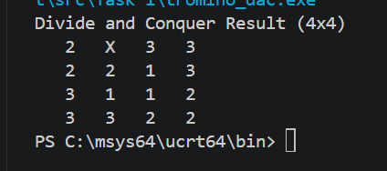

Here, the X is the missing square. The numbers 1, 2, and 3 are the trominoes. If you look closely at the shapes, you'll see that no two L shapes made of the same number ever touch on a flat side.
1.6.2 Brute Force result (4x4)

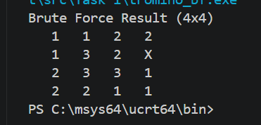

It gets the job done for a small 4x4 grid. But if you change the code to an 8x8, you won't get an output because the program will get stuck in a massive loop of guessing and backtracking.

1.6.2 Output of 16 x 16 board
Divide and Conquer Result (16x16)

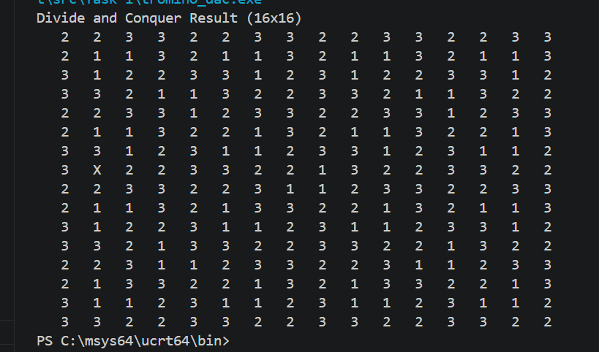

Just like the smaller board, the Divide and Conquer algorithm handles the 16x16 grid effortlessly, finishing almost instantly. The X marks the missing square, and the rest of the board is perfectly tiled with the three colors without breaking the adjacency rule. This perfectly demonstrates how well the recursive geometric approach scales up compared to the brute force method, which struggles heavily at this size.
Brute Force result (16x16)

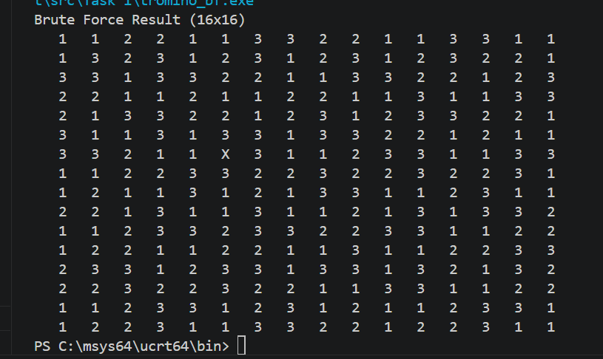

The brute force algorithm manages to get the job done for a 16x16 grid, taking up to 30 seconds to find this valid layout. However, this is its absolute limit. If you change the code to a 32x32 board, the program dies and freezes because it gets stuck in a massive loop of guessing and backtracking.

1.7 Time and space complexity study

1.7.1 Divide and Conquer:
- Time Complexity: It runs in O(N²) time (where N is the side length of the board). I am basically just visiting and filling every square on the board a set number of times. The coloring phase adds a little bit of backtracking, but since the graph of the board is pretty simple, it finishes almost instantly.
- Space Complexity: O(N²) to store the board array, plus O(log N) overhead for the recursion stack since I keep cutting the board in half.

1.7.2 Brute Force:
- Time Complexity: Exponential. It's roughly O(12^{T}) in the worst case scenario (where T is the number of trominoes). For every single empty spot, the computer might try 4 shapes and 3 colors. As the board gets bigger, the number of guesses becomes huge and time taken becomes too long and not worth it.
- Space Complexity: O(N²) for the board, and O(N²) for the recursion stack, because the recursion goes as far as the total number of pieces needed to be placed.

1.8 Comparative evaluation
The Divide-and-Conquer approach leverages the underlying mathematical structure of the problem to determine optimal placement analytically. By identifying exact coordinates for each component without the need for estimation, this method achieves high computational efficiency. Empirical testing demonstrates that for board dimensions of $16 ×16$ and $32 ×32$, the algorithm produces solutions with near-instantaneous latency.
Conversely, the Brute Force (or exhaustive search) method lacks predictive logic, relying instead on systematic trial and error. This approach frequently results in suboptimal configurations where early placements obstruct subsequent moves. While computationally viable for a 4 x 4 grid, the method exhibits significant performance degradation at the 16 x 16 scale and is functionally impractical when applied to 32 x 32 boards or larger; the exponential increase in "dead-end" combinations leads to computational stagnation, effectively preventing the completion of the task within a reasonable timeframe.

1.9 Alternative approaches
A better approach would be to treat the finished board as a mathematical graph and use a standard algorithm like Welsh Powell to color it.
Even better, there are mathematical formulas that can calculate the exact color of a tromino based on its X and Y coordinates on the board. If those formulas were used, coloring of the pieces would be done during the initial placement skipping the second phase entirely.

1.10 Summary
The primary finding of this study underscores the limited scalability of exhaustive search technique. While simple to implement, the exponential time complexity inherent in brute force approaches renders them impractical for large-scale applications.
In contrast, leveraging the geometric properties of the problem through a Divide-and-Conquer paradigm reduces computational latency from an intractable duration to near-instantaneous execution. This shift emphasizes the critical role of algorithmic design in transforming theoretically solvable tasks into computationally efficient solutions.

